

*-/789

**CMDB Inventory Plugin Configuration Guide**

Contents

Introduction 2

Supported Collection Types 3

Data Sources 3

ServiceNow CMDB Integration 4

ServiceNow CMDB Configuration Checklist 4

ServiceNow Credentials 4

ServiceNow CMDB Requirements 4

ServiceNow CMDB Ports 4

ServiceNow Server Data Collection Setup 5

Server Properties 5

Field Definitions 5

Microsoft SQL Inventory CMDB Integration 7

Microsoft SQL Server Data Collection Setup 7

Field Definitions 7

Test Example 8

CSV File Integration 9

CSV File Import Requirements 9

CSV File Import Data Collection Setup Server Properties 12

Field Definitions 12

Custom CMDB ODBC 14

Custom CMDB ODBC Server Data Collection Setup 14

Field Definitions 15

Configuring the SQL Query String 15

Available CMDB values 15

CMDB Client and Bocada Auto-Zoning 17

Auto-zoning Capabilities 17

Auto-zoning Fields 17

Auto-zoning Example 17

CMDB Client Zone Restricting 20

Sample Zone Restriction Query for ServiceNow 20

Sample Query for reconciling client names 21

Reporting Notes 22

Troubleshooting 23

1. Issue: Bocada cannot collect CMDB data from ServiceNow 23

2. Issue: Collection for ServiceNow fails with ODBC driver error 23

3. Issue: User credential issue for ServiceNow 23

4. Issue: Collection for ODBC CSV fails with … Cannot insert duplicate key in object 'dbo.cmdb_clients'… 23

4. Issue: Collection for ODBC CSV fails with *Too few Parameters* 24

5. Issue: CSV test connection error Failed: TestConnectionException: Failed to create database connection due to missing Microsoft Access Text Driver 25

Technical Support 28

# Introduction

The Bocada CMDB (Configuration Management Database) plugin collects asset inventory listings. The asset lists are compared to Bocada backup records. Bocada reports in the CMDB section under Asset Protection will show assets that are:

* **Unprotected**: listed in your CMDB inventory, but for which no backup records are found
* **Non-Inventoried**: backed up assets that are not in your CMDB inventory
* **Protected**: a cross-reference of assets in your inventory and the backed up item found in Bocada

The CMDB plugin has built-in support for ServiceNow, Microsoft SQL Server, CSV file upload, and custom ODBC for any ODBC driver. Hence collection and reporting is provided for any inventory system with minimal effort.

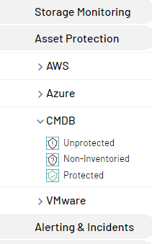

# Supported Collection Types

|  |  |  |
| --- | --- | --- |
| **Collection Type** | **Supported** | **Description** |
| Policy | ✓ | Collects and stores CMDB client inventory data in the Bocada database |

# Data Sources

The plugin relies on any of the following CMDB inventory data sources:

* **ServiceNow API:** open database connectivity (ODBC) driver API which provides read-only access to the database associated with your ServiceNow instance.
* **Microsoft SQL:** integrated support with Windows or SQL authentication.
* **CSV File:** pull data from a CSV text file exported from any asset management inventory.
* **Any ODBC Driver:** with customizable configuration strings and templates.

Each of these methods is described in detail in the sections below.

# ServiceNow CMDB Integration

## ServiceNow CMDB Configuration Checklist

Detailed steps are included below, this is an overview of the requirements and steps to configure ServiceNow CMDB collections on your Bocada Data Collection Server:

* Install Java Runtime Environment 32-bit version (64-bit version is not supported).
* Install 32-bit ServiceNow ODBC driver. For older versions of Windows, such as Windows 2008 R2 you will also need the ServiceNow ODBC Patch (no DNS is needed). Windows 2016 does not require the patch, but it is not clear which other versions of windows do need it.   
  (Note: Make sure to mention JVM.dll path for Java 32-bit during ServiceNow ODBC driver installation. For Example: “C:\Program Files (x86)\Java\jre1.8.0_221\bin\client”).
* Verify ServiceNow CMDB instance name
* Username & password for the ServiceNow CMDB instance with ODBC role
* Add the ServiceNow CMDB server to Bocada under Operations > Backup Servers and set Server Properties
* Work with your ServiceNow engineer to design the SQL Query. The list of available data fields that can be imported is in the section below named Available CMDB values.

## ServiceNow Credentials

For the ODBC driver to connect to your ServiceNow instance it is important to follow these steps:

* Define the user account within ServiceNow. Active Directory accounts or accounts created via a Single Sign-on provider will not work.
* Set the password for the user
* Add the ODBC role to the user account. This will be a read-only user and you may use the ServiceNow security features to limit the access of this user to only the tables that you want to access such as cmdb_ci_computer and/or cmdb_ci_computer tables. Further instructions for this step can be found [on ServiceNow's documentation site.](https://docs.servicenow.com/bundle/newyork-application-development/page/integrate/odbc-driver/task/t_CreateAnODBCUser.html)

## ServiceNow CMDB Requirements

This section lists requirements that must be met prior to collecting data with the Bocada plugin for ServiceNow CMDB.

### ServiceNow CMDB Ports

|  |  |  |
| --- | --- | --- |
| **Service** | **Default Port** | **Note** |
| *HTTPS* | 443 | Bocada DCS will contact ServiceNow via ODBC driver. Verify your DCS can connect to https://<SN_instance_name>.service-now.com/api/ |

Install the ServiceNow ODBC *32-bit* driver (the 64-bit driver is not supported) as per the instructions in the link below. The minimum required version of the driver is **1.0.14**. You will need your ServiceNow Support portal username and password in order to download the ODBC driver. You can use the default settings shown in the ODBC documentation, and you will not need a data source. Note that the ServiceNow ODBC driver requires Java Runtime Environment (JRE) 32-bit version (64-bit version is not supported), and the install instructions for that provide instructions how to install JRE.

<https://docs.servicenow.com/bundle/london-application-development/page/integrate/odbc-driver/task/t_DownloadAndInstallTheODBCDriver.html>

## ServiceNow Server Data Collection Setup

### Server Properties

Backup Server Properties determine how the plugin will interact with the ServiceNow CMDB server and are accessed from the Backup Servers view.

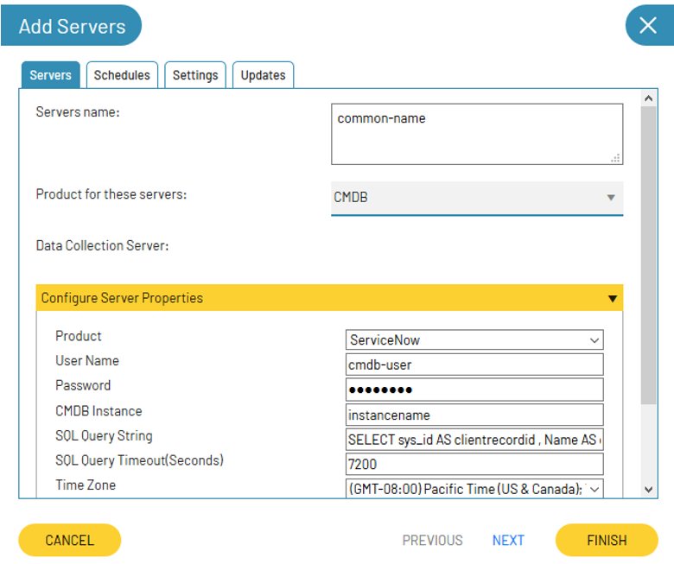

### Field Definitions

#### Server name

Enter the *ServiceNow CMDB Instance* as the Server name. The name does not need to be an exact match to the instance, but name the server so that is clear to which instance the data belongs.

#### User name / Password

Enter the credentials for a user that can access the ServiceNow CMDB instance.

#### CMDB Instance

Name of the ServiceNow instance. For example, if your instance URL is: https://dev12345.service-now.com/ then instance name will be "*dev12345*". Only this short name is needed; the plugin will not accept the fully qualified name.

#### SQL Query String

Enter the SQL string that will be run against the ServiceNow CMDB to gather data. See the Configuring the SQL Query String section of this guide for further information. Note, SQL comments break the query on some ODBC drivers.

#### Time Zone

Select the time zone where the ServiceNow CMDB resides. This setting ensures times are displayed consistently in environments that span multiple time zones.

#### Autozoning

Can select "DoNotCreateZones" if automatically created zones are not desired. by default, Zones are automatically created.

# Microsoft SQL Inventory CMDB Integration

When CMDB data is stored in a Microsoft SQL database, use the integrated Bocada support for Microsoft SQL.

The list of available data fields that can be imported is in the section below named *Available CMDB values.*

## Microsoft SQL Server Data Collection Setup

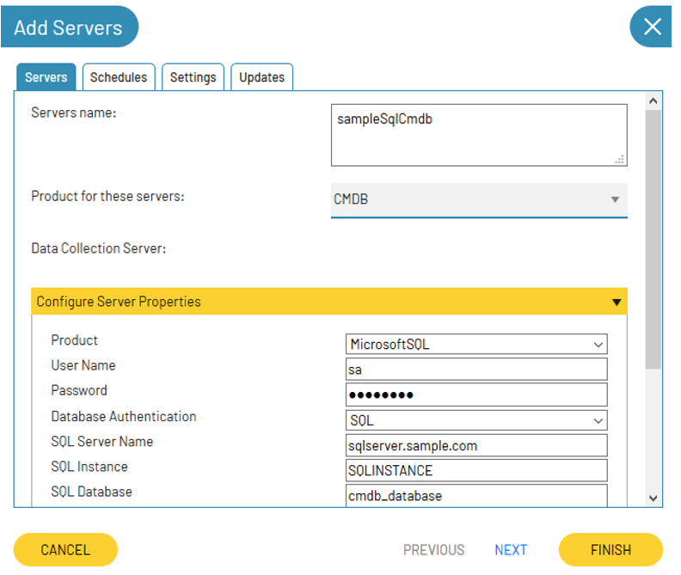

### Field Definitions

#### Server name

This name can be anything, but name the server so that is clear to which instance the data belongs.

#### User Name / Password

This is either SQL authentication, or Windows authentication. For windows authentication, use format of Domain\Username.

#### Database Authentication

Select either SQL authentication, or Windows authentication.

#### SQL Server, Instance, Database

Indicate where the CMDB source database is located.

#### SQL Query String

Enter the SQL string that will be run to pull CMDB data. See the “Configuring the SQL Query String” section of this guide for further information. Note, SQL comments break the query on some ODBC drivers.

#### Time Zone

Select the time zone where the ServiceNow CMDB resides. This setting ensures times are displayed consistently in environments that span multiple time zones.

#### Autozoning

Can select "DoNotCreateZones" if automatically created zones are not desired. by default, Zones are automatically created.

## Test Example

To try out the SQL data source, you can configure the Bocada database as a CMDB server and use the query below. With this working query, Bocada clients will typically show as “Protected Assets” in the CDMB reports.

|  |
| --- |
| Bocada Clients Sample CMDB SQL query |
| SELECT TOP 200 clientfqname, client_id AS clientrecordid  FROM clients WITH(NOLOCK)  ORDER BY client_id DESC |

# CSV File Integration

If you can export your asset management inventory list to a flat CSV file that can be uploaded to Bocada. This can be set up on a schedule, such as a daily scheduled upload. If a daily export of the source inventory data is done to the file then your Bocada inventory will keep in step with your CMDB.

The list of available data fields that can be imported is in the section below named *Available CMDB values.*

## CSV File Import Requirements

Detailed steps are included below, this is an overview of the requirements and steps to configure SNOW CMDB collections on your Bocada Data Collection Server:

* Verify that you have the 32-bit ODBC driver *Microsoft Access Text Driver (*.txt, *.csv)* present on your system. Alternatively, you can use the *Microsoft Text Driver (*.txt; *.csv)*.
* Export your inventory list to a CSV file on a Bocada Data Collection Server.

#### Steps to setup the CSV data source files

|  |  |
| --- | --- |
| Step | Description or Example |
| 1. Create a CSV data file listing your assets. Filename in these examples will be cmdb_sample_data.csv. See example values to the right. The full list of available and required column names is in a table later in this document. The file must be in UTF-8 or ANSI format. | clientfqname, clientrecordid  client_a, 1  client_b, 2  client_c, 3  client_d, 4 |
| 1. Create a dedicated directory folder and put your CSV file in there | C:\sample |
| 1. Add a new text file called schema.ini to c:\sample. This defines the schema and is called schema.ini. Contains the values to the right for this sample. The file must be in UTF-8 or ANSI format. Each column must be defined, even f not later used. | [cmdb_sample_data.csv]  Format=CSVDelimited  ColNameHeader=True  Col1 = "clientfqname" Text  Col2 = "clientrecordid" Text |
| 1. Add a CMDB server to Bocada. Use the name for the server name that you prefer to see in the reports. Select *Custom* for product in the server properties. |  |
| 1. Check to see which ODBC text driver is installed. OPTION 1: “*Access”* driver if available use the following connection string. Note, there are two \\ required in path for best results. | Driver=Microsoft Access Text Driver (*.txt, *.csv);Dbq=c:\\Sample\\;Extensions=csv; |
| 1. OPTION 2: If you do not have the Access Text driver, then you can use the non-Access Text driver. | Driver={Microsoft Text Driver (*.txt; *.csv)};Dbq=c:\sample\;Extensions=csv; |
| 1. Set the SQL query, note that the FROM states the source file name. | SELECT clientfqname, clientrecordid FROM cmdb_sample_data.csv |
| 1. Test connection, checks out the connection to the text driver. |  |
| 1. Run data collection. This example will pull in 4 CMDB values which are visible in the CMDB Unprotected and other assets report | See screenshot below |

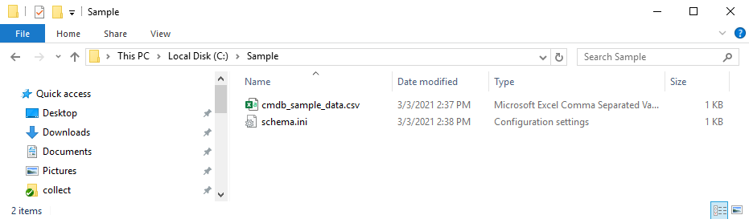

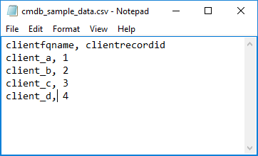

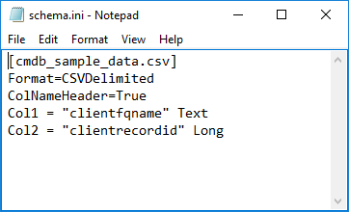

Windows Microsoft Access ODBC Text Driver, which is usually built-in to the OS is used to pull data from a CSV file. Verify that you have this 32-bit driver installed by running the ODBC Data Source Administrator (32-bit) tool. The name must match exactly:

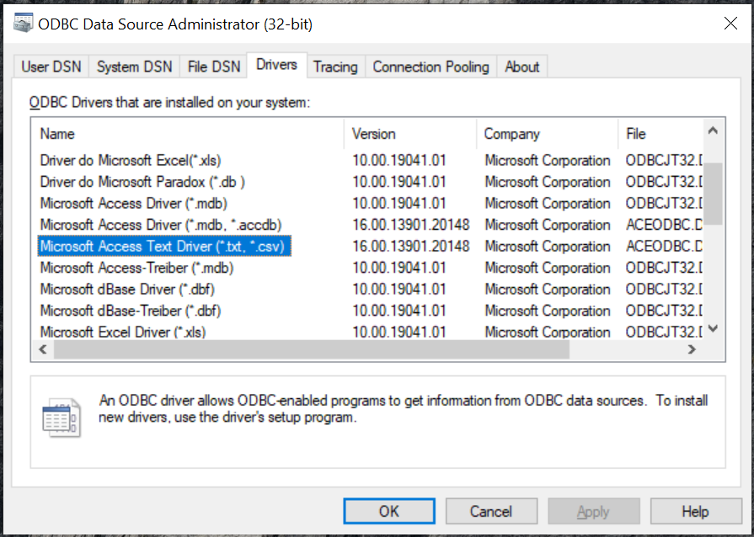

Notes: The Microsoft text driver is case sensitive, see example using LCASE to force capital letters to be lower case. The Microsoft text driver does not accept all of the SQL statements that are recognized by SQL Server. Here is an example SQL query that uses the IIF function and the SWITCH function instead of the CASE statement:

SELECT SystemName AS clientfqname

, LCASE(deviceID) AS clientrecordid

, ipAddress

, macAddress AS ipaddressbackup

, osname

, busUnit AS cmdb_company

, appName AS cmdb_account

, riskRating AS tag

, domain AS custom1

, IIF(commvaultException IS NULL, 'Unknown', 'ExceptionOK') AS custom2

, SWITCH (

status = 'Decom', 'N',

status = 'Test', 'N',

status = 'Pre-production', 'N',

true, 'Y') AS backuprequired

FROM [bocada-inventory.csv]

## CSV File Import Data Collection Setup Server Properties

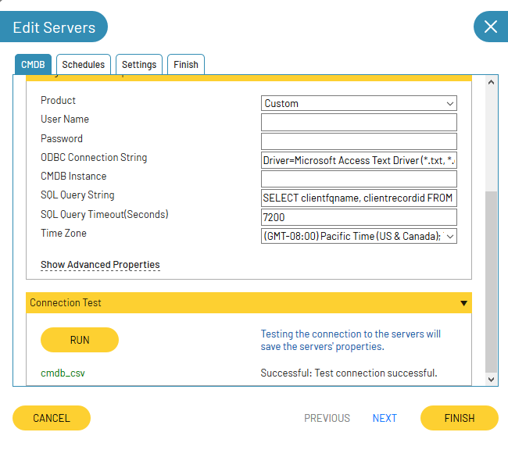

### Field Definitions

#### Product

Choose **Custom**.

#### User Name / Password

Not required for CSV import.

#### ODBC Connection String

Enter as below adjusting your drive letter and file name:

Driver=Microsoft Access Text Driver (*.txt, *.csv);Dbq=c:\\Sample\\;Extensions=csv;

Or, if you do not have the Access driver then enter:

Driver={Microsoft Text Driver (*.txt; *.csv)};Dbq=c:\sample\;Extensions=csv;

#### CMDB Instance

Leave blank.

#### SQL Query String

Enter the SQL string that will be run to pull CMDB data. See the “Configuring the SQL Query String” section of this guide for further information. A simple example is:

SELECT clientfqname, clientrecordid FROM cmdb_sample_data.csv

Note, SQL comments will break the SQL query for some drivers.

#### Autozoning

Can select "DoNotCreateZones" if automatically created zones are not desired. by default, Zones are automatically created.

Example of resulting report:

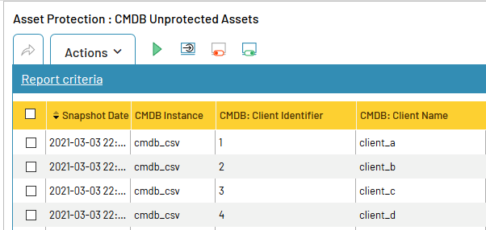

# Custom CMDB ODBC

Any ODBC driver may be used as a CMDB data source. To use custom CMDB, you will need to install your desired ODBC driver and determine the ODBC connection string required to connect to that driver.

The list of available data fields that can be imported is in the section below named *Available CMDB values.*

## Custom CMDB ODBC Server Data Collection Setup

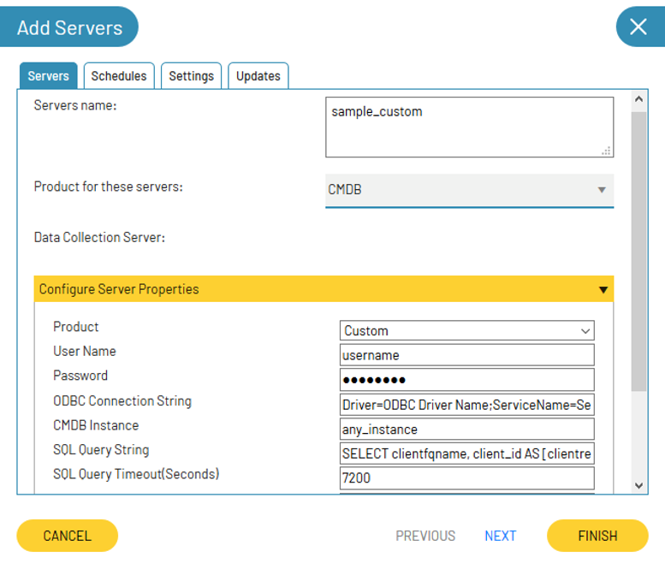

### Field Definitions

#### User Name / Password

These are the user name and password required to connect to the ODBC driver you configure. The values here are optional, but so that password is encrypted, use the templates in the connection string, e.g. **[cmdb_odbc_username_bocada], [cmdb_odbc_password_bocada]** will get replaced with the values you type here.

#### ODBC Connection String with Templates

This string is required to connect to the ODBC driver of your choice with some fields optionally using templates for replacement. Each ODBC driver will fully document the options for the connection string which vary greatly from one product to another.

|  |  |
| --- | --- |
| Template | Description |
| [cmdb_odbc_username_bocada] | Replaced during update with **User Name** server property value |
| [cmdb_odbc_password_bocada] | Replaced during update with **Password** server property value |
| [cmdb_odbc_timeout_bocada] | Replaced during update with **SQL Query Timeout** server property value |
| [cmdb_odbc_instance_bocada] | Replaced during update with **CMDB Instance** server property value |

Supported Templates for ODBC Connection string

# Configuring the SQL Query String

## Available CMDB values

When configuring the SQL Query string in Server Properties, any values retrieved from the ServiceNow CMDB that are listed in the Column Name field in Table 6.1 below will be committed to the Bocada database. Values not listed here will be ignored.

Note, SQL comments will break the SQL query for some drivers.

Items marked “KEY” are used to match backup clients in Bocada with assets aka Configuration Items (CIs). If a zone is specified, then only Bocada backup clients in the named zone will be matched.

|  |  |  |  |
| --- | --- | --- | --- |
| Type | Column Name | Display Name | Description |
| REQUIRED Key | clientfqname | CMDB: Client Name | Required name to cross match with client name in Bocada database, often the CI if ServiceNow |
| Key | bocada_fqzonename | CMDB: Zone | Optional fully qualified zone name to limit mapping of assets to those with this zone. |
| KEY | clientname | CMDB: Alt Name | Additional backup client name, e.g. backup name or short name used to cross reference CMDB name with Bocada backup client name |
| KEY | ZoneType_<*> e.g. ZoneType_Region or ZoneType_NewType | <*> the Zone Type, by default will be created if it does not exist. | Assigns mapped asset to this zone type and zone. This optional key uses the column name specifies a zone type, and contents to specify the zone. For example, if the field **ZoneType_Region** is used, each row value will be zone value. E.G. a row value could be US/West. With this row value, the fully qualified zone Region/US/West will be assigned to the client. By default the zone will be created if it does not exist. Multiple ZoneType_ fields may be used simultaneously. |
| REQUIRED | clientrecordid | CMDB: Client Identifier | CMDB CI unique identifier, e.g. sys_id |
| Info | contact | CMDB: Contact | Info |
| Info | contactemail | CMDB: Contact Email | Info |
| Info | backupproductname | CMDB: Backup Product | Info |
| Info | backupproductversion | CMDB: Backup Product Version | Info |
| Info | osname | CMDB: Operating System | Usually os in ServiceNow |
| Info | osversion | CMDB: Client OS Version | Usually os_version in ServiceNow |
| Info | passexp | CMDB: Password Expiration | Info |
| Info | ipaddress | CMDB: IP Address | Usually ip_address in ServiceNow |
| Info | ipaddressbackup | CMDB: IP Address2 | Info |
| Info | lastaccessdate | CMDB: Last Accessed Time | Usually sys_updated_on in ServiceNow |
| Info | commissioneddate | CMDB: Commissioned Date | Info |
| Info | decommissioneddate | CMDB: Decommissioned Date | Info |
| Info | backuprequired | CMDB: Backup Required | The default value is True.  It's set to False for the following values:   * False * 0 * N * No   Any other value is set to True. |
| Info | tag | CMDB: Tag | Info |
| Info | cmdb_ci_name | CMDB: Configuration Item (CI) | Info |
| Info | cmdb_company | Client info: CMDB Company | Usually dv_company in ServiceNow |
| Info | cmdb_account | Client info: CMDB Account | Info |
| Custom | custom1 | CMDB: Custom Field 1 | Custom informational field displayed in reports |
| Custom | custom2 | CMDB: Custom Field 2 | Custom informational field displayed in reports |

Fields available for Bocada CMDB query

## CMDB Client and Bocada Auto-Zoning – available in Bocada 22.1.03 and later

### Auto-zoning Capabilities

1. Automatically creates new zone types if they don't already exist in the Bocada database.

2. Automatically creates new zones if they don't already exist in the Bocada database.

3. Assign any CMDB clients to Bocada zones regardless of whether they are protected or unprotected.

4. Assign Bocada clients for Protected assets to specified Bocada zone.

### Auto-zoning Fields

One or more columns may be optionally used to specify a Bocada zone type. If a column header is prefixed with "ZoneType_", the rest of the field is the zone type. For example, [ZoneType_Region] indicates the values in the column are zones for "Region". Or [ZoneType_My Zone Type] indicates the values in the column are zones for zone type "My Zone Type", spaces are allowed.

### Auto-zoning Example

As an illustration, the following is a valid query that can be used using the SQL data source on the Bocada database as the CMDB data source:

|  |
| --- |
| SELECT TOP 40  client_id AS clientrecordid,  CASE WHEN p.productname = 'NetBackup' THEN clientfqname + '_unprotected'  WHEN p.productname = 'Commvault' THEN clientfqname  END AS [clientfqname],  CASE WHEN p.productname = 'NetBackup' THEN 'OnPrem\Netbackup'  WHEN p.productname = 'Commvault' THEN 'OnPrem\Commvault'  END AS [ZoneType_CMDB Sample]  FROM clients c WITH(NOLOCK)  JOIN backupproducts p ON p.product_id = c.product_id  WHERE p.productname in ('NetBackup', 'Commvault') AND  (c.clientfqname like '%comv%' or c.clientfqname LIKE '%nbu%') |

The output of this query specifies product specific zones. These zones and zone type "CMDB Sample" Are created automatically during data collection and assigned to both the CMDB clients and Bocada clients.

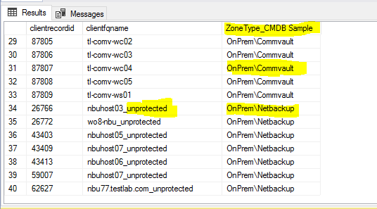

After the CMDB collection completes and CMDB mapping finishes, the zones will appear in Bocada as below.

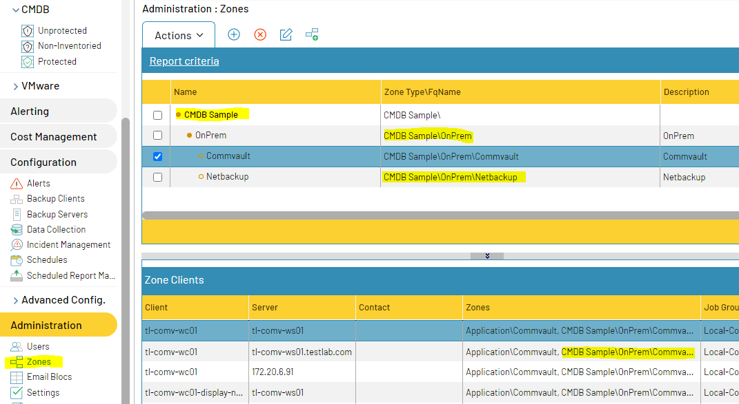Auto-created Zones and Zone types

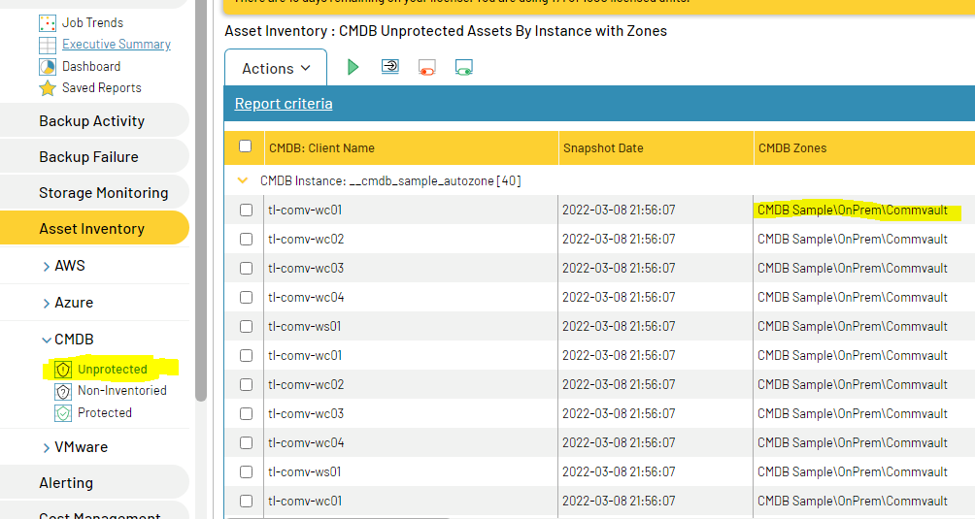Auto-Zoned Unprotected Assets

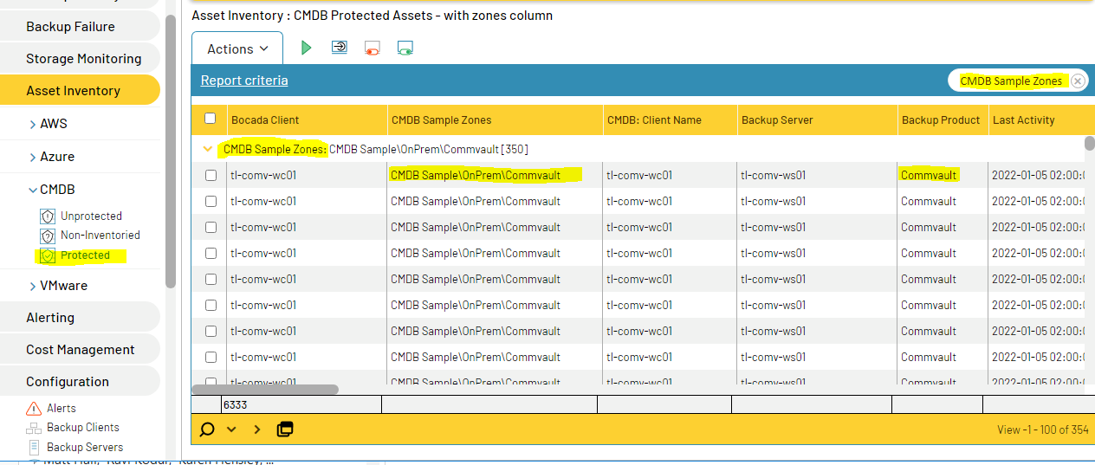Auto-Zoned Protected Assets

Disabling Zone Auto Creation

By default, zones are automatically created when a ZoneType and Zone is specified in a column. If auto zone creation is not desired then you can disable it. In server properties, under advanced properties, set "Autozoning" to "DoNotCreateZones". Zones will still be assigned to the CMDB record, but Bocada backup clients will not be zoned.

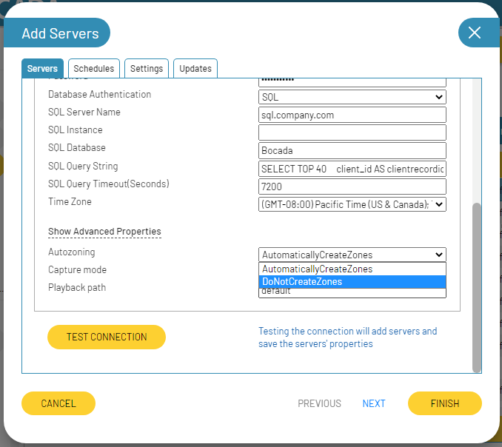

## CMDB Client Zone Restricting

You can optionally limit the Bocada backup clients that can be matched to a CMDB client name. This may be done in an MSP environment where theres is a possibility of duplicate backup client names.

To restrict asset mapping to particular zones for CMDB clients, first add each zone via the Bocada zones view in the normal way, and add Bocada backup clients to those zones as usual. See the Bocada Administration Guide for more details.

If the CMDB SQL query includes a column for bocada_fqzonename then Bocada will record the stated zone for the CMDB asset client in that row. Only the CMDB asset client and Bocada backup clients in with matching zones will be mapped. The CMDB clients can be filtered by the zone name. Standard users assigned to zones will only be able to see the clients in their assigned zones when viewing Bocada CMDB reports.

### Sample Zone Restriction Query for ServiceNow

As an example, a development instance of ServiceNow provided by ServiceNow CMDB will have some CIs already present, such as in the table cmdb_ci_computer, so the following queries can be used for initially or for testing.

|  |
| --- |
| -- Example minimal possible SQL Query with no zone mapping restriction  SELECT sys_id AS clientrecordid  , name AS clientfqname  FROM cmdb_ci_computer |
| -- Example showing zone and use of SN prepend of dv_ to get display value  SELECT sys_id AS clientrecordid  , name AS clientfqname  , 'Customer\' + dv_company AS bocada_fqzonename  , ip_address AS ipaddress  , os AS osname  , os_version AS osversion  FROM cmdb_ci_computer |
| SELECT sys_id AS clientrecordid ​  , CASE WHEN dv_backupname IS NOT NULL ​         THEN dv_backupname        ​    ELSE name       END AS clientfqname ​  , u_backup_name AS clientname ​  , fqdn AS tag ​  , 'CMDB\unassigned' AS bocada_fqzonename ​  , ip_address AS ipaddress ​  , u_backup_type AS backupproductname ​  , u_backups_requested AS backuprequired ​  , dv_u_customer_account_number AS custom1 ​  , install_status AS custom2    ​  FROM cmdb_ci_server     ​  WHERE install_status = 1 |

*Example: Sample CMDB queries*

## Sample Query for reconciling client names

Once the initial CMDB data has been matched to Bocada clients, there will be some unmatched clients. One technique for reconciling the differences is to adjust client names in the CMDB query. This is an effective and quick solution if there are a limited number of unmatched clients. See example 6.4 below.

|  |
| --- |
| SELECT sys_id AS clientrecordid  , CASE WHEN name = 'clientA_SQL' THEN 'clientA'  WHEN name = 'clientA_FS' THEN 'clientA'  ELSE name  END AS clientfqname  , ip_address AS ipaddress  , os AS osname  , os_version AS osversion  , dv_company AS cmdb_company  , sys_updated_on AS lastaccessdate  FROM cmdb_ci_computer |

*Example: Reconciling Overloaded Client Names in CMDB query*

# Reporting Notes

The Bocada plugin for CMDB is used for Backup coverage reporting. The plugin collects a list of assets. Three reports leverage this data:

1. **Unprotected:** shows assets (aka Configuration Items or CIs) for which there is no backup record in Bocada.
2. **Non-Inventoried:** clients being backed up that are not listed in the CMDB. Use this report to identify potentially decommissioned clients that do not need protection, or clients that should be in production but are not properly recorded in the asset inventory.
3. **Protected:** Bocada and CMDB overlap report to show a backup overview for each CI and backup information about that backup client. Note that the CMDB module will first match on exact asset name to exact *clientfqname* selected from the SQL query. Items that do not match will then be checked to see if their short names (no domain name) match. Items that still do not match will then be checked to see if the *clientname* selected from the SQL query matches short or fully qualified long name.

# Troubleshooting

## Issue: Bocada cannot collect CMDB data from ServiceNow

Verify the ServiceNow ODBC driver is working using instructions from ServiceNow:

<https://docs.servicenow.com/bundle/paris-application-development/page/integrate/odbc-driver/task/t_TestingTheODBCDriver.html>

Note: If your version of JRE has changed since the ODBC driver was first installed then you may need to un/reinstall the ServiceNow ODBC driver configuring to point to the correct 32 bit version of Java.

## Issue: Collection for ServiceNow fails with ODBC driver error

The following error in ServiceNow data collection can indicate that you are missing a patch from ServiceNow for the ODBC driver:

**OdbcException: ERROR [HY000] [SN][ODBC ServiceNow driver][ServiceNow Client]Failed to initialize the Service component.  
ERROR [01S00] [SN][ODBC ServiceNow driver]Invalid attribute in connection string: CustomProperties.  
ERROR [HY000] [SN][ODB…**

See the ServiceNow Windows 2008 is known to need the ServiceNow driver patch, and other Windows versions may need it if you see the above error. See information about the ODBC patch here:

<https://docs.servicenow.com/bundle/london-application-development/page/integrate/odbc-driver/task/install-incremental-odbc-fixes.html>

## Issue: User credential issue for ServiceNow

The ServiceNow ODBC driver can be sensitive to special characters. If you have an issue with your username and password, test with credentials that use only letters and numbers. For more information, see [this ServiceNow Knowledgebase article](https://hi.service-now.com/kb_view.do?sysparm_article=KB0538995).

## Issue: Collection for ODBC CSV fails with … Cannot insert duplicate key in object 'dbo.cmdb_clients'…

The following error can occur when trying to collect data from a CSV file:

**Error 545: Cannot execute SQL statement [SQLSTATE=23000] [Microsoft][ODBC Driver 17 for SQL Server][SQL Server]Violation of UNIQUE KEY constraint 'IX_unique_server_cmdb_client_id'. Cannot insert duplicate key in object 'dbo.cmdb_clients'. The duplicate ke**

If you have duplicate entries in your CSV file, then those will be skipped if they are exact matches for the *clientrecordid* and *clientfqname*. But the Microsoft Text ODBC drivers are case sensitive. Soif the *clientfqname* or *clientrecordid* contains a different mix of upper and lower case letters for the duplicate entries, then the driver will present the duplicates to the Bocada SQL server. The SQL Server is case in-sensitive so will reject the records and terminate the collection.

Three solutions are possible:

1. Remove all duplicate records from the CSV input file will solve this problem.
2. Ensure that all duplicate records in the CSV input file are exact duplicates with all lower case or all upper case to solve this problem.
3. Convert the input records to all have only lower case entries. For example, if you have duplicate entries with different mixes of capital letters and lower case letters, and you must use your *clientfqname* to also be the *clientrecordid*, then force the *clientrecordid* to be all lower case using the **LCASE()** function as in the example here:

SELECT clientfqname, LCASE(clientfqname) AS clientrecordid, ...

FROM cmdb_sample_data.csv

## Issue: Collection for ODBC CSV fails with *Too few Parameters*

The following errors can occur when trying to collect data from the CSV file:

**Error 545: OdbcException: ERROR [07002] [Microsoft][ODBC Text Driver] Too few parameters. Expected 1.**

**Error while running SQL:ERROR [07002] [Microsoft][ODBC Text Driver] Too few parameters. Expected.**

Several different problems can cause this error. Please check:

1. Is the correct file name shown in the first line of your schema.ini file?
2. Is there an exact match between the number of columns in your CSV source file as in the count of *colN* lines in your schema.ini file defining the column names, such as:

Col1 = "clientfqname" Text

1. Is the file encoding for both schema.ini and your CSV file plain UTF-8 or ANSI?
   * Your file cannot be in UTF-8-BOM encoding.
   * If you save your CSV from Excel you must choose
     + **CSV (Comma delimited) (*.csv)**
     + You cannot use CSV UTF-8 (Comma delimited) (*.csv) because that will actually save in UTF-8-BOM

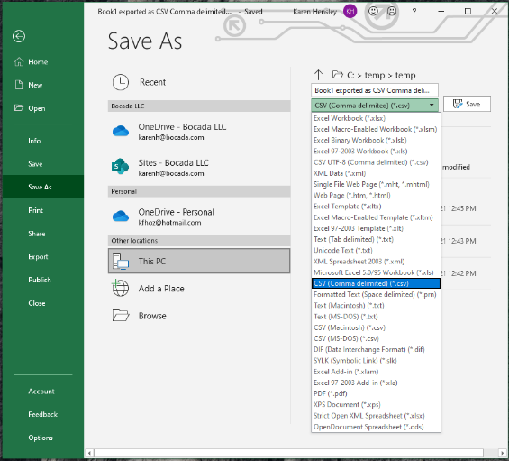

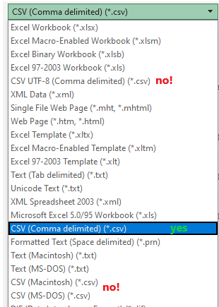

* + You can most easily change the encoding of your files using NotePad++ and setting the Encoding.
  + This is a requirement of the Microsoft ODBC driver.

## Issue: CSV test connection error Failed: TestConnectionException: Failed to create database connection due to missing Microsoft Access Text Driver

Sometimes the Microsoft Access Text Driver is not installed on windows. This will cause your Connection Test to fail as shown below.

**Failed: TestConnectionException: Failed to create database connection**

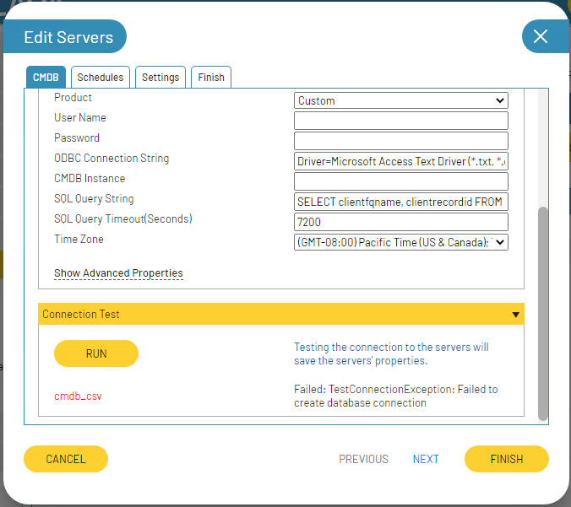

Check the driver installation by running the ODBC Data Sources (32 bit) application.



Go to the Drivers tab and read the names of the drivers carefully. You may see the

**Microsoft Access Driver (*.mdb)**

but not the

**Microsoft Access Text Driver (*.txt,*.csv)**

Problem as shown in this screenshot is that the Access Text driver is missing.

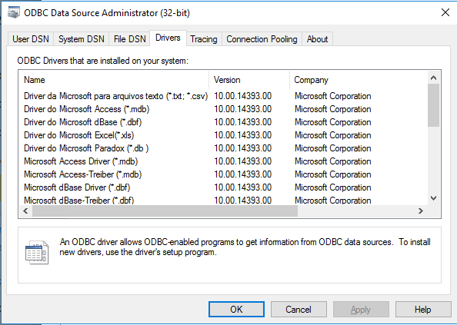

You will need to use the Microsoft Text Driver (*.txt,*.csv) instead. See instructions above for the connection string format to use, similar to:

Driver={Microsoft Text Driver (*.txt; *.csv)};Dbq=c:\sample\;Extensions=csv;

# Technical Support

For technical support or a copy of our standard support agreement, please contact us.

**E-mail:** [support@bocada.com](mailto:support@bocada.com)

**Support Portal:** [https://bocada-support.force.com](https://bocada-support.force.com/)

**Phone:** +1-425-898-2400